Complete STEP 1 ONLY (MarineNet Access) prior to check in. Staff at check in will enroll you in Moodle (your MarineNet Account MUST be created for us to be able to do this).
Use Steps 2-4 to confirm you have been added to the Company Moodle page after check-in.
MarineNet/Moodle Access Instructions
While at TBS it is required that you have access to MarineNet and Moodle (a learning platform contained within MarineNet). MarineNet is different than Marine Online (MOL). If you already have a MarineNet account skip to step 2.
Step 1) MarineNet Access
Follow these steps to get MarineNet access.
- MarineNet site can be found at: https://www.marinenet.usmc.mil/marinenet/
- Click on the signup for a new MarineNet account link.
- Enter your personal information. You can utilize any type of email account but make sure it is entered correctly and you are using an e-mail that you check regularly (The staff will regularly use the Announcement function in Moodle during the course to communicate important information to you and it will go to the e-mail associated with your MarineNet account).
- You should receive an account creation email notification 5-10 minutes after you submit your request.
- If you have issues enrolling online you can call the help desk at 1-888-4DL-USMC (435-8762).
- If you have a CAC, login to your MarineNet account with your CAC credentials in order to associate your profile with your EDIPI identifier.
Step 2) Moodle Access
Once you have a MarineNet account follow these steps to get access to Moodle.
1. Login to MarineNet with your user ID and password.
2. Click on the Instructor-led Courses (Moodle) button on the MarineNet main page. You must click on the MarineNet Moodle button and access the dashboard page in order to be enrolled.
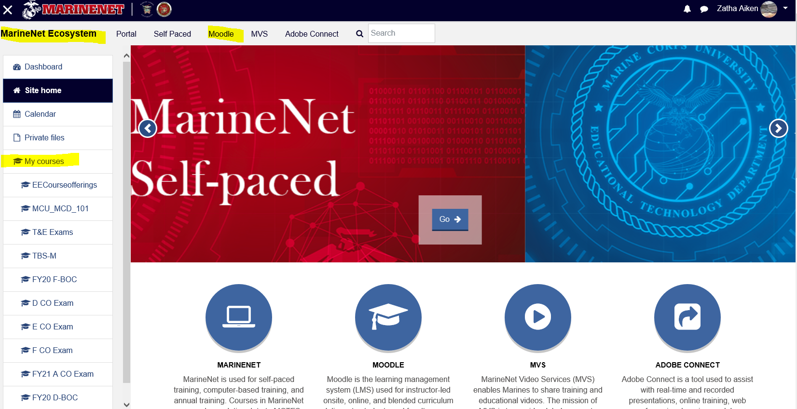


3. Once you have logged into MarineNet and accessed the Moodle sub-page, the Academics section/your Company staff have the ability to enroll you in the Basic Officer Course Moodle page.
4. Once enrolled by Academics or Company Staff, you will see the Company BOC Moodle page in your dashboard on the left side.

